Programme report of African swine flue

During the COVID 19 pandemic an Awareness programme on AFRICAN SWINE FEVER is conducted at Bhebheri Village on 6th May/2020 by Diya Foundation. The resource person Dr. Chandan Sarania was from Veterinary department of Loharghat Health veterinary Centre, under Chayani Block of Kamrup Rural district, Assam. The main purpose of the programme was to make understand the participants about the African swine fever disease. With this specific purpose the programme was started at 11.00 am with the well come address by Mr. Martin Rabha, Secretary of Diya Foundation followed by the specific topics by the resource person Mr. Chandan Sarania.The main topics were a. What is African swine fever, b. Transmission and spread, c.Public health sick, d. Preventions and control and e. Field visits. Resourc person explains to 25 farmers very clearly in details with some photo display. At the end of the programme he visits some piggery units in the village and suggests following scientific measures for it. He also suggests the farmers to build the pig shed scientifically; also thanks Diya Foundation for their active initiation and steps for development of Livestock rearing. Since the COVID 19 Lockdown is going on social distancing among the participants was strictly followed in the programme.
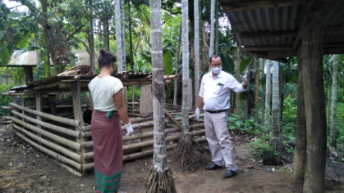
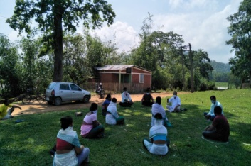

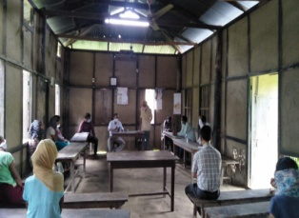
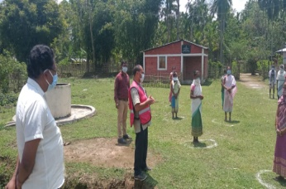

Report and documented by
Ramendra Rabha, Prog. Manager, Diya Foundation

Nutrition Foods for Pregnant Lady: After declaring Lock down for COVID 19 by the Central Government in March/2020 all Government Offices and NGOs all over India had to stop their regular activities and remained at home without work. It was tough to spend without work and movement at home. But many responsible and active social workers tried to find out alternative ways to serve society. For Martin Rabha, founder and Secretary of Diya Foundation also happens same thing; but he tried to find out some ways to serve people during COVID 19 pandemic period; how could he reach people and help. In course of time the Organization gets a mail from Govt. Authority to do volunteer registration. Team accepted it as a blessing and chance to serve people. With this registration and especial permission from police out post and Red Cross Society’s especial recommendation Diya Foundation lays steps to do something for the people of the area. Finally Diya Foundation arranged and supplied relief for around 300 poor households. Out of this for 100 Pregnant and Lactating women Diya Foundation arranged Nutrition supplementary foods for pregnant Lactating women very successfully. After supplying Nutrition food they were supplied
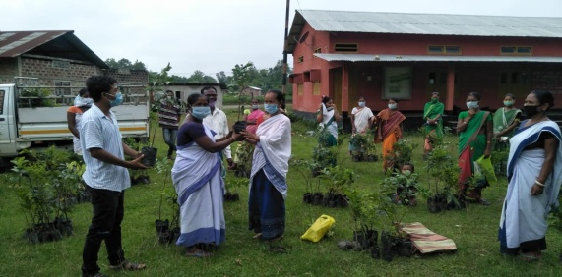
Peer, Guwava, Litchi, Pomegranate and Palm sapling to make small Nutrition in long run.
