Jharkhand 1st Collective meeting and Capacity Building Workshop Report
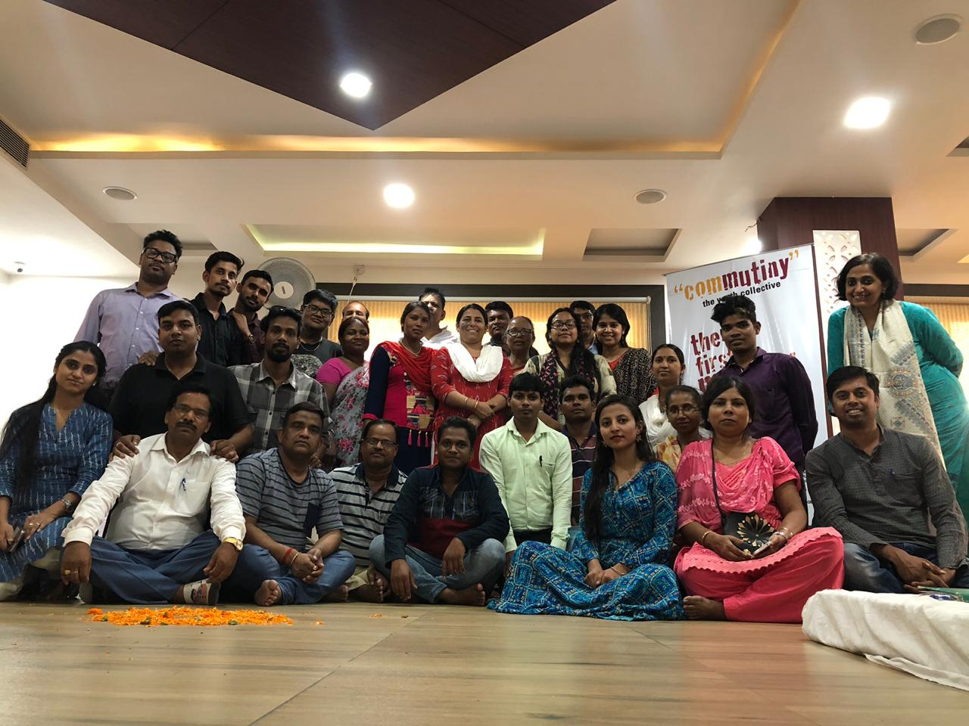

Introduction
A four day residential meet was organized in Jamshedpur from 27-30 May 2019 to explore the process of collectivization of adolescent and youth-focused organizations. With an aim to co-create an adolescent and youth-centric ecosystem in the state of Jharkhand, the three day meet was organized to co-envision the process of collectivization with the newly formed collective members and align their expectations and aspirations.
The 1st Collective meeting and capacity building workshop focused on the critical pillars of institutionalizing a strong foundation of the collective, allowing members to understand the adolescent and youth development lens as different from adolescents and youth for development or as a problem-solving resource.
The meeting focused on three critical pillars – establishing a personal connect between organizations and its members that would help sustain collective thinking and action, capacitating organizations to understand core adolescent and youth-centric development and establishing the fundamentals of the structure and purpose of the Jharkhand state collective.

The meeting began with members introducing themselves through a potluck and presenting before the collective foods from their districts they could relate to and believed would help nourish the space. This approach organically led to a sharing around what this collective space signifies to them, what their expectations of and aspirations for the space is.
As the days proceeded, introduction to the 5th space principles and values helped foreground the culture and values of the collective. Later, an understanding of adolescent and youth development, their needs from the society and that of the society from them facilitated discussions on the same leading to members identifying their passions and competencies that would add strength and value to the collective.
Building on these, members were introduced to the Tatva Analysis of an organization which provides a model to ensure that all components of an entity – from its vision, structure, processes, people to its values and strategies – align and complement each other.
Deliberations around these helped finalize the next steps for the collective in the context of common programming and strengthening the collective approach. Hosted by People for Change with support from ComMutiny –The Youth Collective, the meet helped co-create and imagine the role that the Jharkhand State Collective would play towards enhancing adolescent empowerment and participation.
Participating districts of Jharkhand:
- Ranchi
- West Singhbhum
- East Singhbhum
- Godda
- Koderma
- Deoghar
- Palamu
- Bokaro
- Hazaribagh
- Giridih

AGENDA
Day 0
- Introductions by each member who shared about their culture, food habits and the cultures from their respective districts. This helped build a personal connect and ease in the participants into an unconventional set up.
Day 1
- Reflections from the previous day
- My story
- Ceremonial Potluck
- The 5th space experience
- Presentation by the 6 organization ideas, strategies, impact on the ground.
- Mehfil- designed space for deeper connections.

Day 2
- Reflections from the previous day
- Interaction with Ms Priti Srivastava from UNICEF Jharkhand on Child Rights and Adolescent Participation
- Presentations by 6 organizations
- Perspective Building on Adolescent and Youth Development
- Vision of the collective

Day 3
- Reflections from the previous day
- Introduce Systems Thinking and introduce Tatva: The Elemental Model for the Collective
- Who are we: How is a collective different from an organization?
- Closure and feedback

Day 0
The session began with an ice-breaker following which members participated in an activity called the ‘Dating session’ where in groups of three, members were made to familiarize themselves with one another. They were then asked to share their experience with the larger group.
The session allowed participants to open up to one another in an unconventional and informal manner allowing them to ease in. The excitement to share their journey, made each participant respond spontaneously generating great excitement and helping establish deeper connections.
Day 1
Reflections from the previous day:
The day began with reflections of the previous day. Reflections included acknowledging and sharing of reactions, feelings, observations, and ideas about the activities of the previous day. A general feeling that emerged among the participants was the sense of equality and comfort they all experienced. Most participants shared how the seating arrangement on mattresses gave them the same connect as that with the communities they engage with.

My Story
Participants were asked to pair up with someone they didn’t know and share their fondest childhood memories, a turning point in their lives, why they chose to work with adolescents and youth, and why they were excited to be in the collective meeting.
Interesting stories emerged as participants became nostalgic and were emotional too on sharing their fondest childhood memories. Participants also shared their hardships and each seemed inspired by the other’s life’s struggles. Most shared that working with young people was the need of the hour as they are the future of the country and that investment in them will go a long way.

Ceremonial Potluck
Participants were asked to sit in a circle, with a thaali placed at the centre and each individual had to contribute a special food item representing their region. They were then asked to talk about the significance of the food item they brought and how that it would help enhance the collective space.

For instance, Binod from Sampoorna Gram Vikas Kendra who had brought batasha shared how it related to his character as an open and honest individual. Through this, he wished to bring inclusiveness to the space.

The 5th Space Experience
Each participant had to think of a space where they felt invested in, understood, motivated and not judged and were asked to write down the characteristics/traits of such a space. Some of the commons traits that emerged were a sense of belongingness, equanimity, motivated by peers, freedom to share views, feeling of not being judged, love and a helpful environment.

Next, the movie “Class of Rowdies”, a 5th space production was played that ignited am interest in participants and drew their attention to the idea and need to create safe and non-judgmental spaces in their immediate environment.

Thus, the five 5th space feelings of Love, Freedom, Social hope, Ownership, Growth were brought into focus by the facilitators to the participants by way of discussion and listed on the board. Following this, participants were organized into groups and asked to pick any one 5th space feeling and create an activity around in the form of a play/song/write up, etc to demonstrate the feeling and help the larger group experience the same.

Participants shared how they were each able to relate to the 5 feelings and realized the need to create such spaces in their personal and professional spaces including the collective.

Presentations by 6 Organizations:
As a way of introducing their work and organization’s structure and journey so far to the larger collective, all members put together presentations. This allowed for discussions on each other’s work and an opportunity to understand the on-ground challenges in the districts of Jharkhand.

Mehfil – Designed space for deeper connections

The day ended with a Mehfil which was designed and facilitated by participants themselves to strengthen their bonding, one of the underlying principles of the collective. The evening culminated with each member feeling committed and enthused.

Day 2
Reflections from the previous day
The day began with reflections from the previous day through a card game. Participants were asked to pick a card each representing a value. Heart represented feelings, Spade – suggestion, Diamond – Learning, Clubs – Things to carry forward.

Ajay from Pratigya shared that he felt motivated after getting to know the struggles that members shared.
“I had a feeling that I could express myself more” said Jyoti from YUVA; “I am inspired by the fight against all the problems of our fellow members” said Niraj from Saathee.

Interaction with Priti Srivastava, UNICEF Jharkhand on Child Rights and Adolescent Participation
This session was held over a video conference with Priti Srivastava where participants shared their work with adolescents and youth.

Perspective Building on Adolescent and Youth Development
Youth-hood as the transitional phase of adolescents where mature impressions are formed, is a time when psychosocial intervention is critical. Through discussions on the various theories of youth-hood – transitional, development stage theory, generational and lifestyle choices theory, participants were able to relate to and understand the various stages of youth development.

Later, a play was organized where participants were made to do role plays representing different stakeholders in society including those of a corporate executive, a teacher, a student, a political leader, etc and made to present their perspectives and the needs they would like incorporated in the National Youth Policy.

The participants shared their problems & suggestive measures according to the roles played by them, among the larger group and facilitator was listing them down on the board.

Members were then asked to relate to the four lenses of youth development – Youth development, youth for development, problem-solving and the economic lens. This was an eye opener for most members who related to the youth for development and problem-solving lenses largely.

Participants developed an understanding of how youth development is an ongoing growth process where the community needs to create a 5th space experience to help youth meet their basic personal and social needs to be safe, feel cared for, be valued, be useful, be spiritually grounded, and to build skills and competencies which allow them to function and contribute in their daily lives.

Vision of the collective

Having identified the lenses of youth development and the need for psycho-social intervention, participants were then asked to list the needs of youth from society and that of the society from youth. As members spoke, many realized some of the realities were and how they needed to be addressed.

With this in mind, each participant listed out his/her passions and capacities that would help strengthen the collective and work towards meeting the needs of young people.

As these emerged, participants through an activity that saw intense deliberations, contributed to creating a vision for the collective that would hereafter guide the Jharkhand state collective.
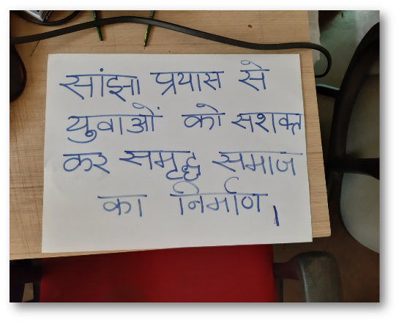

Vision of the collective

Day 3

Systems thinking and Tatva : The Elemental Model for the Collective

The idea of a system as a machine was introduced to make participants understand how elements are interconnected and that there is a need to understand the importance of each.

Having covered the elements of sky (vision), fire (passions), vyakti (capacities) and air (spirit of the collective), participants were introduced to the elements of earth (structure) and water (processes). Structure – that of the collective and the processes that would guide its functioning.

Through discussions on an underlying paradox in systems where efficiency and inclusion as end points drive us in different directions, members were asked to envision how the collective would function keeping in mind the need to create a balance between these two end points, at the same time, allowing for different perspectives and opinions to co-exist.

This was further explained through a difference between an organization and a collective where members were able to relate to the idea of a centralized space and a co-created space.

Intense discussions were had culminating in foregrounding the principles of power-sharing, a structure for decision-making within the collective, realizing the need for each member’s strength to be leveraged and a role therefore assigned to ensure participation and contribution to the collective.

Who are we: How is a collective different from an organization?

The facilitator brought out the paradoxes, or the seven mistakes, to establish the difference between organisations and a collective among the participants. The session allowed participants to understand the underlying challenges and develop the ability to transcend those.

Way Forward
- Identification of partnerships in both institutional and non-institutional settings to create cohorts for adolescents for the Jagrik journey
- Second capacity building workshop in August, 2019
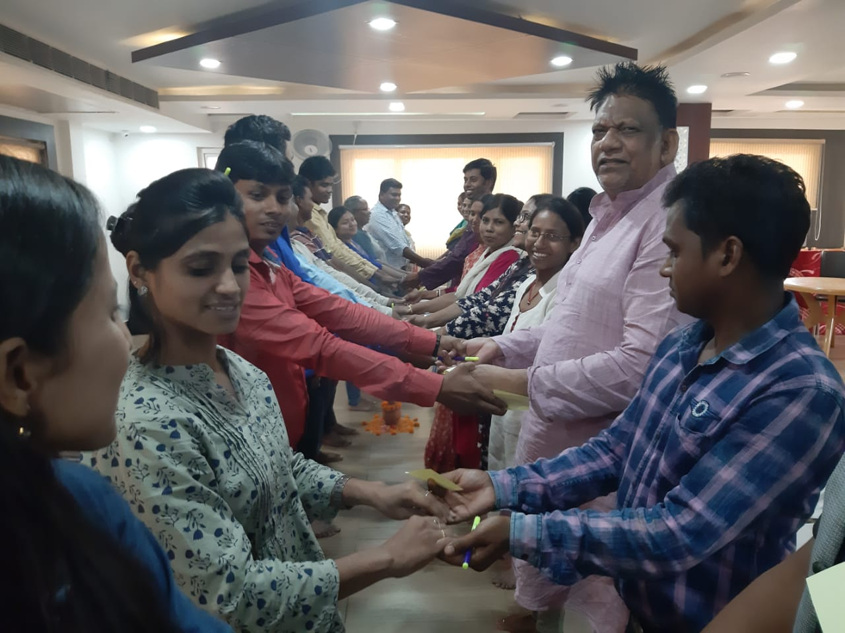

Closure and feedback

The 3-day meet ended with members sharing some suggestions and feedback. Appreciating the unconventionality of the space, participants shared how the meeting helped facilitate an understanding of some core issues and relate to the stark reality that society today presents; that of the youth being under-represented and the need for their participation in key decision-making processes.

Some of the feedback participants shared –
- “Didn’t feel the gap between trainer and participants” - Shekhar from Sahyogini
- “Inspired by the thought and practices we have been put together, learnt how to provide direction to the youth” said Gautam from sahyogini
- “This was an interesting way to conduct a workshop. Everyone participated. It didn’t feel like a training at all. Perhaps the sessions could have been a little shorter” said ShambhuLal from Vikas Kendra.
- “We would now be looking through lens of youth development more, earlier we only used to look at problems and try finding its solutions, but now youth development would be our focus” saidSarojit from Jago Foundation.
- “Youthful spirit maintained. We were here not just in a project mode. We experienced the 5th space” said Darshana from Samekit Jan Vikas Kendra.

